TASK REPORT

Video Player

Kavindu Dodanduwa

10/10/2018

Table of Contents

LIST OF FIGUARES 2

LIST OF TABLES 2

1 Introduction 3

2 Technology Selection and System Design 3

3 Implementation 5

3.1 Initial investigations 5

3.2 Media Source Extensions 6

3.3 Different quality levels and dynamic quality handling 8

3.4 Encoding tools – ffmpeg and MP4BOX 8

3.5 Limitations 8

4 Installation Guide 9

4.1 Prerequisites 9

# LIST OF FIGUARES

Figure 1 Overall Architecture 3

Figure 2 Sample request to retrieve video chunk 4

Figure 3 Sample request for video chunk 6

# LIST OF TABLES

Table 1 Tested MIME types against browsers 7

# Introduction

Goal of this task was to create a video player capable of handling videos of various quality. Each video will be broken into small chunks to. At the client end, these videos chunks should be retrieved, appended to player and played. Selection of the chunk and its quality is determined by a pre-defined policy.

A major requirement of the task was to use HTML5 video player. This enables the video player to utilize live streams as well as support flash videos.

# Technology Selection and System Design

There were few considerations when selecting the appropriate technology. First consideration was the requirements of the task. Implementation required to support HTML5 video player. So, the design should support that. Secondly, the technical competency of author had to be considered. Author’s previous experience on Python, HTML and Docker was used when designing the system.

As the second step, an overall architecture diagram was created to identify and understand system requirements. This architectural diagram is given below,



Figure 1 Overall Architecture

As highlighted in “Figure 1”, there will be two major components in the implementation. They are the client and the server.

Client component focuses on video player which faces the end user. It is running on a browser and is written and developed using web technologies. Also, client implementation will be hosted on a http server. This http server will be deployed as a docker image for ease of testing and to support multiple ecosystems (ex: - Windows, Mac OS or Linux).

On the other hand, server component focuses on video hosting and retrieval logic. Implementation runs on a Python http server. Same as the client, server will be deployed as a docker image. Hosted videos are chunked for specific lengths. Each segment is hosted in different qualities (ex:- high and low). Server receives chunk retrieval requests which contain identification of the video, requesting chunk id and the expected quality of the chunk. A sample request will look similar to below,

Figure 2 Sample request to retrieve video chunk

**http://<server>:<port>/videos?id=abc&chunk=abc1.webm&quality=high**

Server also has the capability to send a metadata document to client. This metadata document contains information on video length, available segments and available quality profiles. This way client gets the ability to dynamically detect and request video chunks at runtime.

In combination, both client and server complete the design of the video player. Having two separate systems allow individual systems to be altered independently from each other. For example, changing the server component can be done as long as it adheres to the request-response contract established between client and server.

Besides client and server implementation, there were few tools used for video encoding and chunking. Author mainly used ffmpeg and MP4BOX during the implementation process.

# Implementation

First step of the implementation was to create a GIT repository. This allows author to maintain the code base in a standard manner as well as provide a platform to share work with evaluators. Following repository was created for this purpose,

[**https://github.com/Kavindu-Dodan/video-player.git**](https://github.com/Kavindu-Dodan/video-player.git)

The implementation was done in iterations. Each week author set few goals and at the end of the week progress was reported. At the same time GIT repository was updated with latest codes. Iterative approach helped author to improve the implementation gradually. Following sections contains details of four iterations (from 11/09/2018 to 10/10/2018) showing implementation details went into final product.

## Initial investigations

Initial investigations stated with HTML5 Video player. This element is defined as **<video>** in HTML pages. Developers can simply hard code the source of the video. When the web page is opened in a browser video source will be played automatically.

To test out capabilities of **<video>** element, author first tried to dynamically alter video source through JavaScript. This was doable in very short time, but video playback was not smooth. There were gap visible when video segments changed.

Along with these initial investigations, author started working on the server side. Implementation of server side was done on top of CherryPy HTTP server. Video chunks were stored inside server. Chunks were exposed through RESTful web URLs. From client side, JavaScript was used to retrieve these chunks. Then they were appended to **<video>** element for playback.

Furthermore, Docker was used to run both client and server. From client end, author used NGINX to host and expose HTML page with built in video player. From server end, author used lightweight alpine Linux. On top of alpine Linux image, author created a Python environment to run CherryPy server.

With successful video serving and play back, initial investigation phase was concluded. These investigations, making of Docker images created the foundation for more improved version of the video player.

## Media Source Extensions

As the next step, author started investigations on Media Source Extensions (MSE). MSE is a W3C maintained recommendation originated in late 2016. The main intention of MSE is to allow JavaScript to manipulate media elements, dynamically. It supports both audio and video playback. Below diagram is extracted from the standard documentation to highlight the standard’s intentions,

Figure 3 Sample request for video chunk

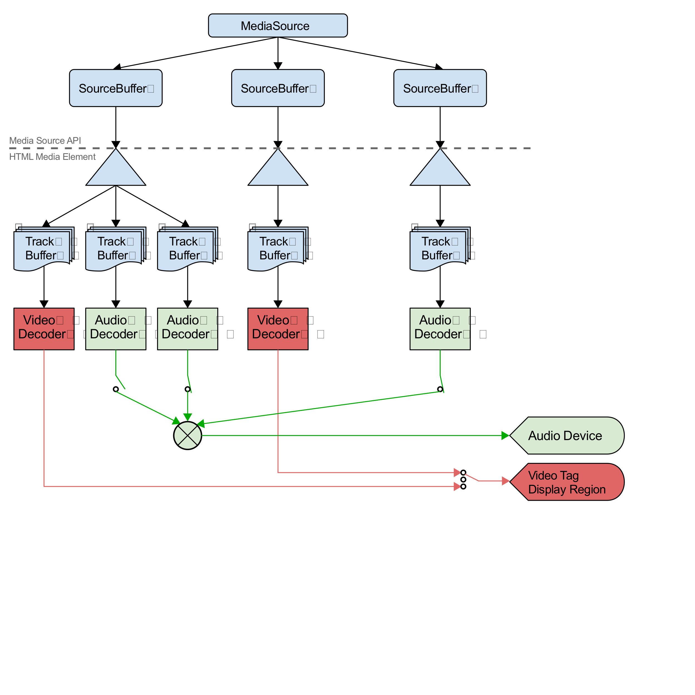

Though there was a specification and some guides, it was difficult to understand the key concepts of MSE when it comes to implementation. Adding to that author came across video playback issues due to MIME type. One such issue came with MP4 video playback issues due to encoding issues.

Due to these initial issues, author used WEBM video type to test out initial implementations of MSE based video player. Following are the steps involved in playing video segments through MSE based approach.

1. Identify the **<video>** element that needs to be set the video playback
2. Attach a MediaSource element by creating an object URL
3. Add a SourceBuffer to MediaSource created above with the MIME type of video avialble
4. Wait till **<video>** element open the object URL created above
5. Attach an event listener to handle SourceBuffer appended events
6. Append the video chunk to SourceBuffer

After the 6th step above, the event created in 5th step will be triggered when video chunk is fullt appended. This allows more and more video segments to be added to SourceBuffer. This is the approach used by author to create the video player.

Also, it’s a must to detect the final segment of the elements. For this author used metadata document retrieved at the very beginning (before requesting video chunks) from server. This metadata document contained number of chunks, chunk IDs, total video length and MIME type of the video. This information was essential for video player initiation as well as playback. For example, end of video chunks was detected from the number of chunks included in the metadata document. Also, MIME type was detected from it.

When working with MSE, a key challenge faced was to handle MIME types. Different browsers had different support for MIME types. Below types summaries tested MIME types and supported browsers,

Table 1 Tested MIME types against browsers

|  |  |  |  |
| --- | --- | --- | --- |
| MIME TYPE \ BROWSER | Chrome | Firefox | Safari |
| WEBM  (vorbis, vp8) | YES | YES | NO |
| MP4  (mp4a.40.2, avc1.640034)  (avc1.64001F) | YES | YES | YES |

## Different quality levels and dynamic quality handling

With the success of MSE based video player implementation, next step was to serve videos with different quality levels.

Due to limited time left, author selected two quality levels, high and low. Different of quality between these two levels resulted for chunk size difference of four folds. Video player allows users to select video quality at the beginning. By default, video is served in *adaptive* quality. In this setting, video player will alter video chunk quality depending on network bandwidth. Network bandwidth is calculated at the runtime and the next chunk will be fetched based on bandwidth quality. For testing bandwidth greater than or equal to 500 kill Bytes per second allowed player to use chunks in high quality. If bandwidth was less, player switched to low quality chunks.

## Encoding tools – ffmpeg and MP4BOX

For video encoding and splitting, author used ffmpeg and MP4BOX. These tools were new to author, so there was a steep curve.

These tools were used for following purposes,

1. Splitting videos to chunks
2. Encoding chunked videos
3. Identify MIME type in MSE supported format

Once mastered different commands, author created few scripts to support the automation of chunking and encoding processes.

## Limitations

Following are the limitations of the implementation

1. Investigation on WebSocket to transmit video data
2. Only two quality levels for videos
3. No buffering and delaying chunk loading (All chunks are loaded when SoureBuffer is read for a new append)

# Installation Guide

## Prerequisites